CUSTOMER SEGMENTATION ANALYSIS

# Download the dataset

1. **load the dataset into the tool**

In [1]:

**import** pandas **as** pd

**import** numpy **as** np

**import** seaborn **as** sns

**import** matplotlib.pyplot **as** plt

**from** matplotlib **import** rcParams

In [2]:

df**=**pd**.**read_csv('Mall_Customers.csv')

df**.**head()

|  |  |  |  |  |  |
| --- | --- | --- | --- | --- | --- |
| Out[2]: | **CustomerID** | **Gender** | **Age** | **Annual Income (k$)** | **Spending Score (1-100)** |
|  | **0** 1 | Male | 19 | 15 | 39 |
|  | **1** 2 | Male | 21 | 15 | 81 |
|  | **2** 3 | Female | 20 | 16 | 6 |
|  | **3** 4 | Female | 23 | 16 | 77 |
| In [3]: | **4** 5 | Female | 31 | 17 | 40 |

df**.**shape

Out[3]:(200, 5)

In [4]:

df**.**columns **=** [ "CustomerID" , "Gender" , "Age" , "AnnualIncome" , "SpendingScore" ]

df**.**drop ( columns **=** [ "CustomerID" ] , inplace **= True** )

In [5]:

df**.**head()

|  |  |  |  |  |
| --- | --- | --- | --- | --- |
| Out[5]: | **Gender** | **Age** | **AnnualIncome** | **SpendingScore** |
|  | **0** Male | 19 | 15 | 39 |
|  | **1** Male | 21 | 15 | 81 |
|  | **2** Female | 20 | 16 | 6 |
|  | **3** Female | 23 | 16 | 77 |
| In [6]: | **4** Female | 31 | 17 | 40 |

df**.**shape

Out[6]:(200, 4)

# Perform below visualizations

1. Univariate analysis

In [7]: plt**.**plot(df**.**AnnualIncome)

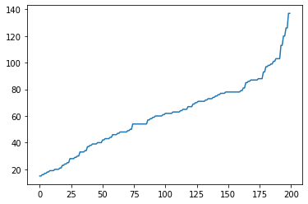Out[7]:[]

1. Bivariate analysis In [8]:

sns**.**jointplot(df**.**Age,df**.**SpendingScore)

plt**.**show()

/usr/local/lib/python3.7/dist-packages/seaborn/_decorators.py:43: FutureWarning: Pass the foll owing variables as keyword args: x, y. From version 0.12, the only valid positional argument w ill be `data`, and passing other arguments without an explicit keyword will result in an error or misinterpretation.

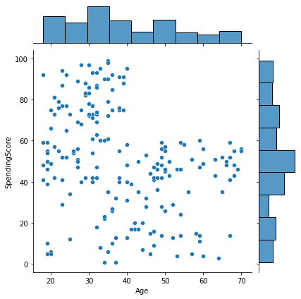FutureWarning

1. Multivariate analysis In [9]:

sns**.**pairplot(df)

Out[9]:

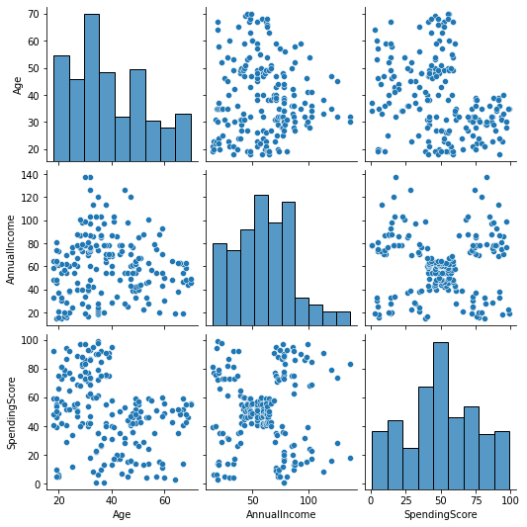

# Perform descriptive statistics on the dataset.

In [10]:

df**.**describe()

Out[10]:

|  |  |  |  |
| --- | --- | --- | --- |
|  | **Age** | **AnnualIncome** | **SpendingScore** |
| **count** | 200.000000 | 200.000000 | 200.000000 |
| **mean** | 38.850000 | 60.560000 | 50.200000 |
| **std** | 13.969007 | 26.264721 | 25.823522 |
| **min** | 18.000000 | 15.000000 | 1.000000 |
| **25%** | 28.750000 | 41.500000 | 34.750000 |
| **50%** | 36.000000 | 61.500000 | 50.000000 |
| **75%** | 49.000000 | 78.000000 | 73.000000 |
| **max** | 70.000000 | 137.000000 | 99.000000 |

# Check for Missing values and deal with them.

In [11]:

df**.**isnull()**.**sum()

Out[11]:Gender 0

Age 0

AnnualIncome 0

SpendingScore 0

dtype: int64

# Find the outliers and replace them outliers

In [12]:

sns**.**boxplot(df**.**Age)

/usr/local/lib/python3.7/dist-packages/seaborn/_decorators.py:43: FutureWarning: Pass the foll owing variable as a keyword arg: x. From version 0.12, the only valid positional argument will be `data`, and passing other arguments without an explicit keyword will result in an error or misinterpretation.

FutureWarning

Out[12]:

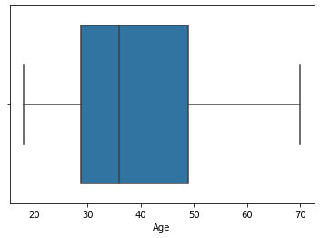

In [13]:

sns**.**boxplot(df**.**AnnualIncome)

/usr/local/lib/python3.7/dist-packages/seaborn/_decorators.py:43: FutureWarning: Pass the foll owing variable as a keyword arg: x. From version 0.12, the only valid positional argument will be `data`, and passing other arguments without an explicit keyword will result in an error or misinterpretation.

FutureWarning

Out[13]:

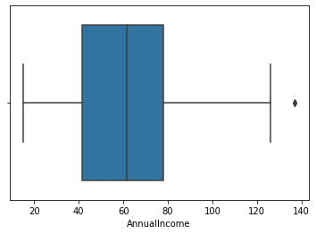

In [14]:

sns**.**boxplot(df**.**SpendingScore)

/usr/local/lib/python3.7/dist-packages/seaborn/_decorators.py:43: FutureWarning: Pass the foll owing variable as a keyword arg: x. From version 0.12, the only valid positional argument will

be `data`, and passing other arguments without an explicit keyword will result in an error or misinterpretation.

FutureWarning

Out[14]:

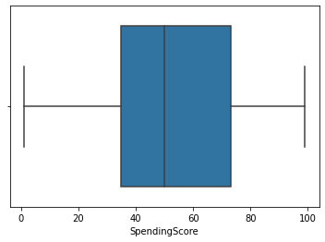

In [15]:

p99**=**df**.**AnnualIncome**.**quantile(.99)

p99

Out[15]:126.1099999999999 In [16]:

df['AnnualIncome']**=**np**.**where(df['AnnualIncome']**>**p99,p99,df['AnnualIncome'])

In [17]:

sns**.**boxplot(df**.**AnnualIncome)

/usr/local/lib/python3.7/dist-packages/seaborn/_decorators.py:43: FutureWarning: Pass the foll owing variable as a keyword arg: x. From version 0.12, the only valid positional argument will be `data`, and passing other arguments without an explicit keyword will result in an error or misinterpretation.

FutureWarning

Out[17]:

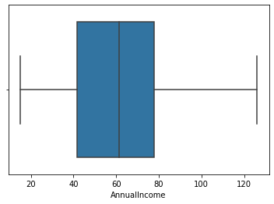

# Check for Categorical columns and perform encoding.

In [18]:

**from** sklearn.preprocessing **import** LabelEncoder

le**=**LabelEncoder()

In [19]:

df**.**Gender**=**le**.**fit_transform(df**.**Gender) df**.**head()

Out[19]:

|  |  |  |  |
| --- | --- | --- | --- |
| **Gender** | **Age** | **AnnualIncome** | **SpendingScore** |
| **0** 1 | 19 | 15.0 | 39 |
| **1** 1 | 21 | 15.0 | 81 |
| **2** 0 | 20 | 16.0 | 6 |
| **3** 0 | 23 | 16.0 | 77 |
| **4** 0 | 31 | 17.0 | 40 |

# Scaling the data

In [20]:

**from** sklearn.preprocessing **import** MinMaxScaler

scale**=**MinMaxScaler()

In [21]:

dfscaled**=**pd**.**DataFrame(scale**.**fit_transform(df),columns**=**df**.**columns)

dfscaled**.**head()

Out[21]:

|  |  |  |  |
| --- | --- | --- | --- |
| **Gender** | **Age** | **AnnualIncome** | **SpendingScore** |
| **0** 1.0 | 0.019231 | 0.000 | 0.387755 |
| **1** 1.0 | 0.057692 | 0.000 | 0.816327 |
| **2** 0.0 | 0.038462 | 0.009 | 0.051020 |
| **3** 0.0 | 0.096154 | 0.009 | 0.775510 |
| **4** 0.0 | 0.250000 | 0.018 | 0.397959 |

# Perform any of the clustering algorithms

In [22]:

**from** sklearn **import** cluster

In [23]:

error**=**[]

**for** i **in** range(1,15):

kmeans**=**cluster**.**KMeans(n_clusters**=**i,init**=**'k-means++',random_state**=**0) kmeans**.**fit(dfscaled)

error**.**append(kmeans**.**inertia_)

In [24]:

error

Out[24]:[88.32732686560692, 38.917720543638254,

31.26877470963097,

24.036006946598846,

20.531319465343856,

17.537959674200287,

15.093012172474253,

12.820270787214906,

11.1191731120412,

9.795501557418575,

8.799306558312036,

8.104289419716354,

7.396527700846332,

6.793483643796583]

In [25]:

plt**.**plot(range(1,15),error)

Out[25]:[]

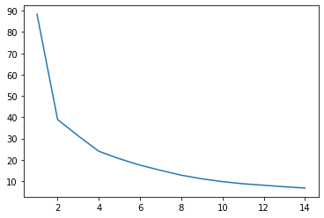

In [26]:

kmmodel**=**cluster**.**KMeans(n_clusters**=**7,init**=**'k-means++',random_state**=**0)

In [27]:

kmmodel**.**fit(dfscaled)

Out[27]:KMeans(n_clusters=7, random_state=0)

In [28]:

TargetCustomers**=**kmmodel**.**predict(dfscaled)

TargetCustomers

|  |  |  |  |  |  |  |  |  |  |  |  |  |  |  |  |  |  |  |  |  |  |
| --- | --- | --- | --- | --- | --- | --- | --- | --- | --- | --- | --- | --- | --- | --- | --- | --- | --- | --- | --- | --- | --- |
| Out[28]:array([6, | 6, | 4, | 4, | 4, | 4, | 2, | 4, | 5, | 4, | 5, | 4, | 2, | 4, | 5, | 6, | 4, | 6, | 5, | 4, | 6, | 6, |
| 2, | 6, | 2, | 6, | 2, | 6, | 2, | 4, | 5, | 4, | 5, | 6, | 2, | 4, | 2, | 4, | 2, | 4, | 2, | 6, | 5, | 4, |
| 2, | 4, | 2, | 4, | 4, | 4, | 2, | 6, | 4, | 5, | 2, | 5, | 2, | 5, | 4, | 5, | 5, | 6, | 2, | 2, | 5, | 6, |
| 2, | 2, | 6, | 4, | 5, | 2, | 2, | 2, | 5, | 6, | 2, | 6, | 4, | 2, | 5, | 6, | 5, | 2, | 4, | 5, | 2, | 4, |
| 4, | 2, | 2, | 6, | 5, | 2, | 4, | 6, | 2, | 4, | 5, | 6, | 4, | 2, | 5, | 6, | 5, | 4, | 2, | 5, | 5, | 5, |
| 5, | 4, | 2, | 6, | 4, | 4, | 2, | 2, | 2, | 2, | 6, | 2, | 2, | 1, | 4, | 0, | 3, | 1, | 5, | 1, | 3, | 1, |
| 4, | 0, | 3, | 0, | 2, | 1, | 3, | 0, | 2, | 1, | 4, | 0, | 3, | 1, | 3, | 0, | 2, | 1, | 3, | 1, | 2, | 0, |
| 2, | 0, | 3, | 0, | 3, | 0, | 2, | 0, | 3, | 0, | 3, | 0, | 3, | 0, | 2, | 1, | 3, | 1, | 3, | 1, | 2, | 0, |
| 3, | 1, | 3, | 1, | 2, | 0, | 3, | 0, | 2, | 1, | 2, | 1, | 2, | 0, | 2, | 0, | 3, | 0, | 2, | 0, | 2, | 1, |

3, 1], dtype=int32)

# Add the cluster data with the primary dataset

In [29]: dfscaled**.**insert(loc**=**4,column**=**'TargetCustomers',value**=**TargetCustomers)

In [30]: dfscaled**.**head()

Out[30]:

|  |  |  |  |  |
| --- | --- | --- | --- | --- |
| **Gender** | **Age** | **AnnualIncome** | **SpendingScore** | **TargetCustomers** |
| **0** 1.0 | 0.019231 | 0.000 | 0.387755 | 6 |
| **1** 1.0 | 0.057692 | 0.000 | 0.816327 | 6 |
| **2** 0.0 | 0.038462 | 0.009 | 0.051020 | 4 |
| **3** 0.0 | 0.096154 | 0.009 | 0.775510 | 4 |

**Gender Age AnnualIncome SpendingScore TargetCustomers 4** 0.0 0.250000 0.018 0.397959 4

# Split the data into dependent and independent variables.

In [31]:

x**=**dfscaled**.**iloc[:,:**-**1]

x**.**head()

|  |  |  |  |  |  |
| --- | --- | --- | --- | --- | --- |
| Out[31]: |  | **Gender** | **Age** | **AnnualIncome** | **SpendingScore** |
|  | **0** | 1.0 | 0.019231 | 0.000 | 0.387755 |
|  | **1** | 1.0 | 0.057692 | 0.000 | 0.816327 |
|  | **2** | 0.0 | 0.038462 | 0.009 | 0.051020 |
|  | **3** | 0.0 | 0.096154 | 0.009 | 0.775510 |
|  | **4** | 0.0 | 0.250000 | 0.018 | 0.397959 |
| In [32]:  y |  |  |  |  |  |
| **=**dfscaled**.**TargetCustomers  y**.**head() | | | | | |
| Out[32]:0 | 6 | | | | |
| 1 | 6 | | | | |
| 2 | 4 | | | | |
| 3 | 4 | | | | |
| 4 | 4 | | | | |

Name: TargetCustomers, dtype: int32

# Split the data into training and testing

In [33]:

**from** sklearn.model_selection **import** train_test_split

x_train,x_test,y_train,y_test**=**train_test_split(x,y,test_size**=**0.2,random_state**=**0)

# Build the Model

In [34]:

sns**.**lineplot(dfscaled**.**AnnualIncome,dfscaled**.**TargetCustomers)

/usr/local/lib/python3.7/dist-packages/seaborn/_decorators.py:43: FutureWarning: Pass the foll owing variables as keyword args: x, y. From version 0.12, the only valid positional argument w ill be `data`, and passing other arguments without an explicit keyword will result in an error or misinterpretation.

FutureWarning

Out[34]:

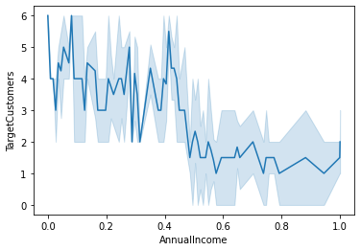

In [35]:

**from** sklearn.linear_model **import** LogisticRegression

model**=**LogisticRegression()

# Train the Model

In [36]:

model**.**fit(x_train,y_train)

Out[36]:LogisticRegression() In [37]:

train_pred**=**model**.**predict(x_train)

train_pred

|  |  |  |  |  |  |  |  |  |  |  |  |  |  |  |  |  |  |  |  |  |  |
| --- | --- | --- | --- | --- | --- | --- | --- | --- | --- | --- | --- | --- | --- | --- | --- | --- | --- | --- | --- | --- | --- |
| Out[37]:array([3, | 2, | 2, | 6, | 2, | 2, | 5, | 6, | 2, | 0, | 2, | 4, | 2, | 4, | 1, | 2, | 5, | 2, | 2, | 2, | 1, | 2, |
| 0, | 4, | 0, | 5, | 2, | 0, | 6, | 2, | 0, | 2, | 6, | 2, | 3, | 2, | 5, | 6, | 6, | 1, | 1, | 2, | 3, | 0, |
| 5, | 2, | 4, | 5, | 2, | 1, | 4, | 5, | 2, | 2, | 2, | 5, | 0, | 5, | 2, | 2, | 3, | 0, | 2, | 6, | 2, | 5, |
| 6, | 5, | 0, | 6, | 4, | 4, | 4, | 5, | 4, | 0, | 6, | 2, | 0, | 6, | 6, | 4, | 5, | 4, | 4, | 2, | 4, | 2, |
| 3, | 3, | 2, | 6, | 4, | 2, | 0, | 1, | 3, | 6, | 1, | 4, | 2, | 5, | 4, | 5, | 6, | 6, | 6, | 3, | 5, | 4, |
| 4, | 1, | 6, | 2, | 4, | 5, | 0, | 5, | 2, | 2, | 4, | 1, | 4, | 3, | 1, | 5, | 5, | 4, | 1, | 0, | 4, | 6, |
| 5, | 2, | 4, | 2, | 0, | 2, | 6, | 6, | 0, | 6, | 2, | 2, | 2, | 4, | 4, | 2, | 4, | 5, | 4, | 2, | 6, | 4, |

|  |  |  |  |  |  |
| --- | --- | --- | --- | --- | --- |
| 6, | 2, | 3, | 2, | 4, | 3], dtype=int32) |
| **15.Test the Model** |  |  |  |  |  |

In [38]:

test_pred**=**model**.**predict(x_test)

test_pred

Out[38]:array([5, 3, 5, 5, 1, 3, 4, 5, 2, 2, 6, 4, 2, 2, 5, 4, 6, 3, 4, 5, 0, 1,

4, 0, 5, 1, 1, 1, 2, 2, 4, 5, 3, 4, 2, 0, 1, 4, 2, 2], dtype=int32)

# 16.Measure the performance using Evaluation Metrics.

In [39]:

**from** sklearn.metrics **import** accuracy_score,confusion_matrix,classification_report

In [40]:

print('test accuracy score: ',accuracy_score(y_test,test_pred))

print('train accuracy score: ',accuracy_score(y_train,train_pred))

test accuracy score: 0.95

train accuracy score: 0.95625

In [41]:

pd**.**crosstab(y_test,test_pred)

Out[41]:

|  |  |  |  |  |  |  |  |  |  |
| --- | --- | --- | --- | --- | --- | --- | --- | --- | --- |
|  | **col_0**  **TargetCustomers** | **0** | **1** | **2** | **3** | **4** | **5** | **6** | |
| **0** | 3 | 0 | 0 | 0 | 1 | 0 | 0 | |
| **1** | 0 | 6 | 0 | 0 | 0 | 0 | 0 | |
| **2** | 0 | 0 | 9 | 0 | 0 | 0 | 0 | |
| **3** | 0 | 0 | 0 | 4 | 0 | 1 | 0 | |
| **4** | 0 | 0 | 0 | 0 | 7 | 0 | 0 | |
| **5** | 0 | 0 | 0 | 0 | 0 | 7 | 0 | |
| **6** | 0 | 0 | 0 | 0 | 0 | 0 | 2 | |
| In [42]:  pd**.**crosstab(y_train, | | | |  |  |  |  |  | |
| Out[42]: **col_0 TargetCustomers**  **0** | | **0**  16 | **1**  0 | train_pr  **2 3**  0 0 | | | ed  **4**  1 | )  **5**  0 | **6**  0 |
| **1** | | 0 | 11 | 0 | | 0 | 0 | 0 | 1 |
| **2** | | 0 | 0 | 45 | | 0 | 0 | 0 | 0 |
| **3** | | 0 | 0 | 0 | | 11 | 0 | 3 | 0 |
| **4** | | 0 | 0 | 1 | | 0 | 29 | 0 | 0 |
| **5** | | 0 | 0 | 0 | | 0 | 0 | 19 | 1 |
| **6** | | 0 | 0 | 0 | | 0 | 0 | 0 | 22 |